Grade 2/3 News
Issue 5:1 January 2017
Important Dates The New Year promises to bring new beginnings.
Fri., Jan.27th – P.A. Day We hope that all of our families take time to enjoy the winter season and try new activities this year.
- Mrs. Does, Mrs. Harper and Mrs. Maltby
Language Arts  This month the students will have exposure to narrative writing through picture books and short stories. Students will write their own personal narrative as well as create their own fractured fairy tale.  In reading we will be focusing on making inferences, questioning and finding important ideas.  Students are encouraged to read at least 20 minutes every day. Keep filling out the reading logs!  Math  For both grade 2 and 3, we will be finishing our Numbers Unit and starting the Measurement Unit in the first week back. We will be focusing on millimetres, centimetres and metres. Following these investigations, the study of time using both digital and analogue clocks as well as temperature will be addressed. Please use the links on the website for additional at-home practice suggestions.  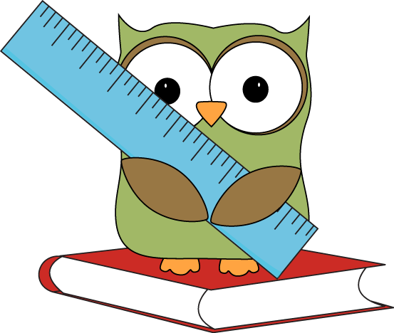 | Science  The Grade 2 students have been working hard on their Animals Unit with Mr. Michie. They have completed their first project and will be presenting their findings and posters to the class. This will be part of the oral communications mark.  The students will continue to look at animal adaptations with Mr. Michie.  In class, we have started the Liquids and Solids science unit. We have defined matter as everything around us! The students can identify a variety of liquids and solids and have completed a few experiments to illustrate the properties of liquids and solids. We will continue this unit for the next 4 weeks.  The Grade 3 students have completed the study of plants. The plant reports they produced were amazing! All of the grade 3 teachers were very pleased with the students’ oral presentations. It was a wonderful learning experience creating the google slides.  We will now investigate forces causing movement in the upcoming weeks. Students will discuss the question “What is a force?” and determine, through inquiry, how forces impact our daily lives. Students will be asked to make a toy that uses one of the forces discussed in class. | Stay tuned for a letter with a plan attached for the students to complete and present to the class closer to the end of the unit.  Dance  Our class started Dance in December. We have explored some of the key elements of dance (moving at different speeds and different levels) and have demonstrated the ability to move and control our bodies in a specified space. We have discussed the importance of dance in Pioneer times and learned one of these dances. In January the students will concentrate on creating short dance pieces and communicate their understanding of works of dance through discussions and writing.  Grade 2 Swimming  Grade Two families; please look for the permission form for swimming in your child’s book bag. It should be coming home soon!

