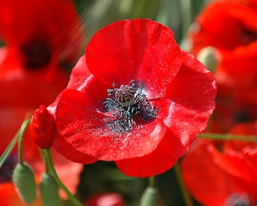 Grade 2/3 News
Important Dates  Nov. 3rd ,10th , 17th - Grade 3 Swimming  Nov. 11th – Remembrance Day  - Progress Reports Home  Nov. 16th – Picture Retakes  Nov. 16th-18th – Interviews  Nov. 18th – PA Day – No School  Nov. 25th – Spirit Day – PJ Day  Nov. 30th – Grade 3’s to Simcoe County  Museum | It is difficult to believe that we have shared two full months together as a class! The time has gone very quickly and the students have been working hard on a variety of projects and assignments. It is wonderful to watch the children grow and develop as successful, polite, and unique individuals.  -Mrs. Maltby
In Class …
Language Arts  The students will continue to work on paragraphs and recount writing (first, then, next, finally). We will begin to look at procedural writing. The students will also produce a report based on their science inquiries. More information will follow in the upcoming weeks. | Math  We will be studying Patterns in November. The students will identify, describe, extend and create repeating patterns,  Our next unit of study will be Numbers to 200, and adding and subtracting to 18 (Grade 2). The grade 3’s will study Numbers to 1000, including adding and subtracting 3 digit numbers. | Grade 3 Swimming  Swimming starts on Nov. 3rd. It will run for the next three weeks. Students are reminded to bring a swimming suit and towel in a plastic bag. We will be swimming until 3 o’clock. Students may be a little late for the regular dismissal time.  Science  Our science units, Animals (grade 2) and Plants (grade 3) will continue throughout November.
Agendas  Please check and initial agendas daily. School trip forms will need to be filled out and returned to school promptly. | Report Cards and Parent Teacher Interviews  Report cards go home November 11th. Interviews are November 16th – 18th. | FYI  In January, the Grade 2 students will participate in a 10 week swimming program.

